Docker

1. Overview
- Repo to learn Docker with examples.
- Contributions welcome.
- YouTube playlist: Link

2. Containers
- Standard unit of software packaging code + dependencies.
- Run reliably across environments.
- Bundle includes:
  - Application
  - Required libraries
  - Minimum system dependencies
Lightweight compared to VMs.
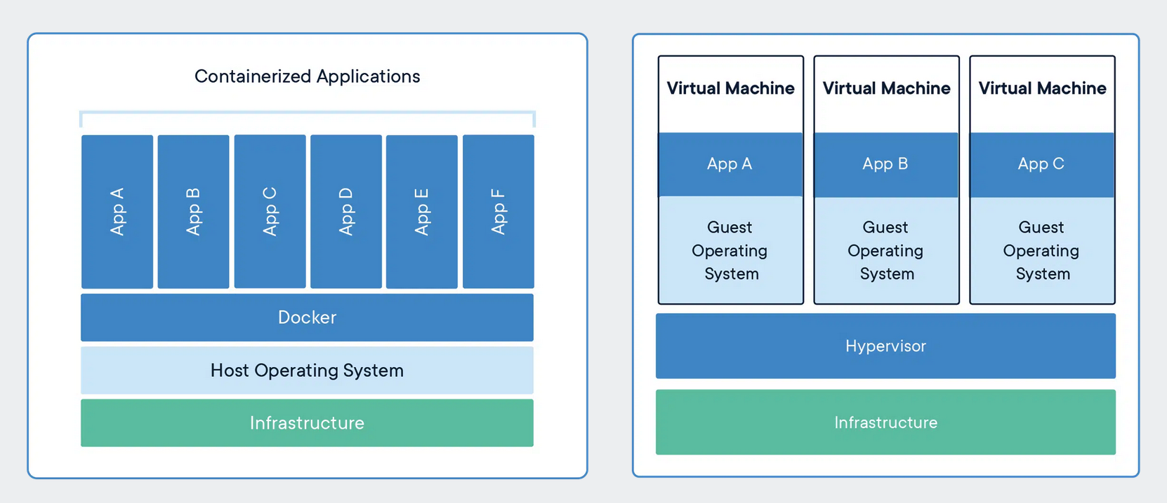

3. Containers vs Virtual Machines
Feature | Containers | Virtual Machines
Resource Use | Shares host OS kernel (light) | Full OS + hypervisor (heavy)
Portability | Highly portable | Less portable
Security | Moderate isolation | Full isolation
Management | Easier, fast deployment | Complex, slower

4. Why Containers Are Lightweight
- Share host OS kernel & libraries.
- Include only what's needed for app.
- Example:
  - Ubuntu container: ~22 MB
  - Ubuntu VM: ~2.3 GB (~100x bigger)
Files in container images:
- /bin, /sbin, /etc, /lib, /usr, /var, /root
Files/resources from host:
- File system (bind mounts)
- Networking stack
- System calls (kernel)
- Namespaces (process isolation)
- cgroups (resource limits)

5. Docker
- Docker: platform to build, run, and share containers.
- Implements containerization technology.

Docker Architecture
- Docker Daemon (dockerd) → core service
- Docker Client → interacts via CLI/API
- Docker Desktop → GUI for Mac/Windows/Linux
- Docker Registries → store & share images

Docker Lifecycle
- docker build → build image from Dockerfile
- docker run → run container from image
- docker push → share image to registry
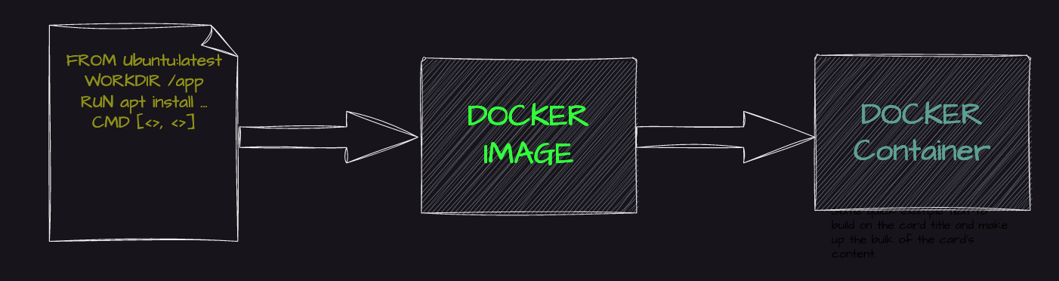

6. Key Docker Terminology
- Docker Daemon: Manages images, containers, networks, volumes
- Docker Client: CLI interface (docker run, docker pull)
- Docker Desktop: GUI & tools for container management
- Docker Registry: Store/pull images (Docker Hub, private)
- Dockerfile: Step-by-step instructions to build an image
- Images: Read-only templates for containers

7. Install Docker (Ubuntu Example)
sudo apt update
sudo apt install docker.io -y
sudo systemctl start docker
sudo usermod -aG docker ubuntu
- Verify: docker run hello-world
- Ensure Docker daemon is running: sudo systemctl status docker

8. First Docker Image & Container
- Clone repo:
git clone https://github.com/iam-veeramalla/Docker-Zero-to-Hero
cd examples
- Login to DockerHub:
docker login
- Build Image:
docker build -t <dockerhub-username>/my-first-docker-image:latest .
- List Images:
docker images
- Run Container:
docker run -it <dockerhub-username>/my-first-docker-image
- Push Image:
docker push <dockerhub-username>/my-first-docker-image

9. Summary
- Containers are lightweight, portable, and isolated.
- Docker simplifies building, running, and sharing containers.
- First hands-on steps: clone repo → build → run → push image.

Docker Networking – Pointwise Notes

1. Overview
- Docker networking allows containers to communicate with each other and the host system.
- Containers are isolated by default, so networking is needed for communication.
- Default network drivers: bridge and overlay.
docker network ls
Example output:
NETWORK ID NAME DRIVER
xxxx nonenull
xxxx host host
xxxx bridge bridge

2. Bridge Networking
- Default network mode in Docker.
- Creates a private network between host and containers.
- Containers can communicate with each other and the host.
- To create a custom bridge network:
docker network create -d bridge my_bridge
- List networks:
docker network ls
- Run container on custom bridge network:
docker run -d --net=my_bridge --name db training/postgres
- Containers on different networks are isolated.
- You can connect an existing container to a bridge network:
docker network connect my_bridge web

3. Host Networking
- Containers share the host system’s network stack.
- Container uses same IP and network configuration as host.
- Run container with host network:
docker run --network="host" <image_name> <command>
- Less isolated → potential security risk.
- Not all images are compatible; check documentation or use bridge first.

4. Overlay Networking
- Enables communication between containers on different Docker hosts.
- Useful for multi-host Docker Swarm or Kubernetes clusters.

5. Macvlan Networking
- Allows container to appear as a physical host on the network.
- Each container gets its own MAC address.
- Useful for legacy network setups where containers must be on the same LAN as the host.

✅ Key Takeaways
- Bridge: default, private container network.
- Host: shares host network, fast but less isolated.
- Overlay: multi-host communication.
- Macvlan: container acts like a physical network device.

Docker Volumes – Pointwise Notes

1. Problem Statement
- Docker containers have ephemeral file systems.
- Data inside a container is lost when the container is deleted.
- Need a way to persist data beyond container lifetime.

2. Solutions for Data Persistence
- Volumes
- Bind Mounts (host directory as a mount)

3. Volumes
- Volumes store data on the host file system, separate from the container.
- Data persists even if the container is deleted or recreated.
- Managed by Docker and can be backed up, moved, and shared across containers.

Commands
- Create a volume:
docker volume create <volume_name>
- Run container with a volume:
docker run -it -v <volume_name>:/data <image_name> /bin/bash
- /data in the container maps to <volume_name> on host.
- Any data written in /data is persisted in the volume.
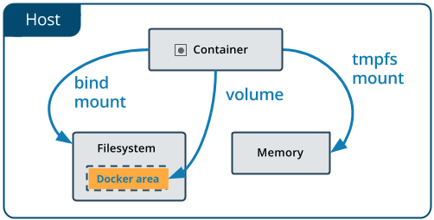

4. Bind Mounts (Host Directory as Mount)
- Mount a specific host directory into the container.
- Useful for simple use cases like development, testing, or config files.

Commands
docker run -it -v <host_path>:<container_path> <image_name> /bin/bash
- <host_path> → directory on host
- <container_path> → directory inside container
- Changes in container directly affect the host directory.

5. Key Differences: Volumes vs Bind Mounts
Feature | Volumes | Bind Mounts
Management | Managed via Docker API | Managed by host filesystem
Flexibility | Can move, backup, share across containers | Limited to host directory
Use Case | Complex, persistent, production data | Simple, development/testing use
Isolation | More isolated from host | Directly tied to host filesystem

✅ Summary
- Volumes: Preferred for persistent, production-grade storage.
- Bind Mounts: Suitable for simple, host-linked scenarios.

Docker Commands – Pointwise Notes

1. Image Commands
- docker images → List all images on the host machine.
- docker build → Build an image from a Dockerfile.
- docker rmi <image_name> → Remove an image from the host.
- docker pull <image_name> → Download an image from a registry.
- docker push <image_name> → Upload an image to a registry.

2. Container Commands
- docker run <image_name> → Run a Docker container.
  - Common arguments:
    - -d → Run container in background (detached mode)
    - -p <host_port>:<container_port> → Port mapping
    - --name <container_name> → Assign a name to container
  - docker run --help → See all options.
- docker ps → List running containers.
- docker stop <container_name> → Stop a running container.
- docker start <container_name> → Start a stopped container.
- docker rm <container_name> → Remove a stopped container.
- docker exec -it <container_name> <command> → Run a command inside a running container.

3. Network Commands
- docker network → Manage Docker networks:
  - Create network: docker network create <name>
  - List networks: docker network ls
  - Connect container to network: docker network connect <network> <container>
  - Disconnect container: docker network disconnect <network> <container>
  - Remove network: docker network rm <network>

✅ Summary
- Images: build, images, rmi, pull, push
- Containers: run, ps, stop, start, rm, exec
- Networks: network create/ls/connect/disconnect/rm

